Important points

1. One common example is the List returned by [Arrays.asList()](http://download.oracle.com/javase/6/docs/api/java/util/Arrays.html" \l "asList%28T...%29): it is documented **not** to support any structural modification (i.e. removing or adding elements) (emphasis mine):

Returns a **fixed-size** list backed by the specified array.

1. Ms🡺 non static inner class cannot have static methods🡺
2. To add not null constraint after creating a table🡺alter table tablename modify colname datatype(size) not null;
3. what is the difference between where and having clause🡺

The **HAVING clause** was added to SQL because the WHERE keyword could not be used with aggregate functions. The**difference between** the two is in the relationship to the GROUP BY **clause**: WHERE comes before GROUP BY; SQL evaluates the WHERE **clause** before it groups records.

1. Subquery reduces performance
2. Query to find out a particular column is referenced in which and all tables

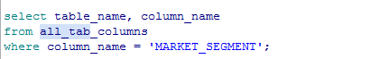

Doubts and Pending works

1. Find out few datatypes that used in your app db tables
2. Is composite key and EmbeddedId concept is same?
3. What is Candidate key and alternate key
4. 